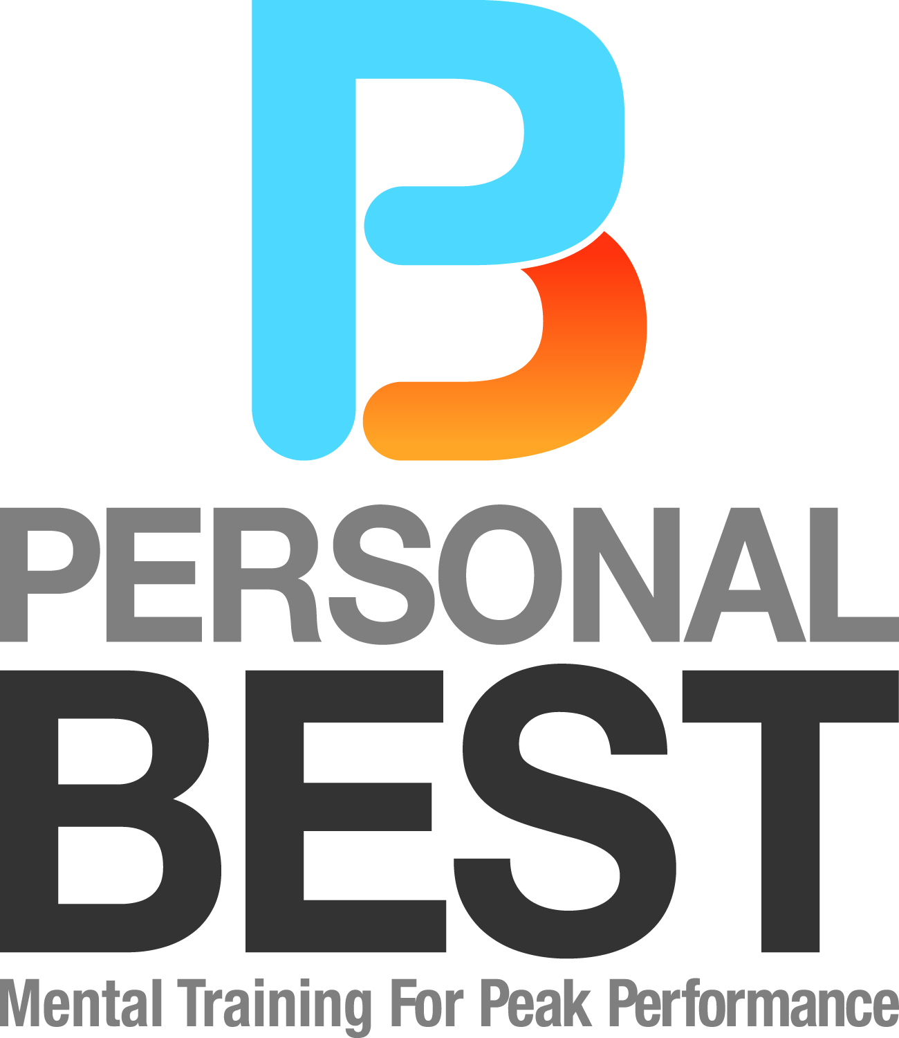

Mike Boyle Strength & Conditioning is pleased, once again, to present Personal Best and it’s highly touted program …...Mental Toughness for Peak Performance.

Educators/coaches Pete Moscariello and Scott Farris have been recognized nationally as top peak performance trainers and have conducted over 250 successful workshops from Maine to North Carolina for businesses, student-athletes, college and high school athletic teams, parent groups, drama clubs, dance studios, school faculties, administrators, families, and individuals. Our program is designed to help participants increase their chance for success in performance – athletic, academic, career, or personal.

Simply stated, Mental Toughness is the ability to perform at peak levels regardless of the circumstance and conditions. When athletes are asked what percentage of performance is “mental”, typical responses range from 75% to 95%. Yet, most athletes spend less than 5% of their training time on the mental game!

We all need Mental Toughness because our daily performance is hard and presents us with frequent challenges and obstacles. In Personal Best’s one-of-a-kind program, you will learn how to meet those challenges by learning the specific skills listed below:

- Creating a Present Moment Focus | - Using Visualization for Success
- Developing a Positive Mindset | - Responding effectively to Adversity
- Using Positive Self-Talk | - Performing with Unbeatable Confidence
- Focusing on Process over Outcomes | - Using the 5 R’s of Peak Performance
- Controlling the “Control-ables”

"Our team experienced a great workshop with the Personal Best team of Pete Moscariello and Scott Farris. They really did a great job of engaging the athletes and supplying them with useful techniques to apply the principals they were exposed to. They truly "coached" our players during the workshop. Our guys really benefited from the time spent with Coach Moscariello and Coach Farris. You can see the guys using the routines every day in our games and practices. We expect Personal Best to be a big part of every season.”
--John Casey, Head Baseball Coach, Tufts University

“Personal Best had a profound impact on my sales career at EMC. The messaging and techniques that Personal Best teaches are exactly what I needed to better my performance as an EMC Sales Rep. In my opinion, the entire EMC community would benefit from the strategies that Personal Best promotes.”

-- Jim Murphy, Director of Sales Strategy, Data Protection & Availability Division, EMC Corp;
Elected to Reading HS and Northeastern University Hall of Famer. Former professional football player.

“Coach Farris and Coach Moscariello have greatly influenced my attitude, mental toughness, and ultimately my success as a high school, college, and professional baseball player. I would highly recommend Personal Best to athletes at any level.”
--Steve Langone, Head Major League Scout, Boston Red Sox
Elected Reading HS and Boston College Hall of Fame. Former professional baseball player.

Read testimonials from Personal Best’s clients:

Personal Best has worked with youth, high school, College (Div. I, II, III)
and Professional Athletes and with athletic teams from
fff
Babson College, Bowdoin College, Fitchburg State University, Lyndon State College, Roger Williams University as well as numerous high schools, in various sports, including Reading, Belmont, Billerica, Concord-Carlisle, Lexington, Manchester-Essex, Newburyport, Norwood, Pentucket, Wayland, Winchester, Woburn
- all with rave reviews!

Personal Best guarantees that you will enjoy our positive energy and upbeat atmosphere. Each of you will be an active participant in the sessions, as instructors use demonstration and video clips to enhance learning.
The goal of the class is for you to learn positive, proven, and healthy skills that you can apply - today!

Personal Best Instructors

Pete Moscariello:

- Head Baseball Coach at Reading (MA) High School for 35 years;
- Coaching Record: 560 wins, 208 losses; .729 winning pct.
- 14 league championships; 1 state championship
- 8 times Middlesex League Coach of the Year; 2 times Boston Globe Division II Coach of the Year
- MIAA Baseball Coach of the Year 2011
- Eastern Mass Baseball Umpires Association Coach of the Year 2011
- Inducted Mass. Baseball Coaches Association Hall of Fame
- Inducted Reading Memorial High School Hall of Fame
- Mass Baseball Coaches Association President’s Award 2012
- Owner/Director of Reading Baseball School, 30 years

Scott Farris:

- Owner of 4 successful businesses
- Assistant Baseball Coach Reading High School 20 years
- 2010 National BCA District I Assistant Coach of the Year
- 2009 Mass. Baseball Coaches Association Assistant Coach of the Year
- 1992 Mass. HS Wrestling Coaches Association Assistant Coach of the Year
- Private Mentor/Tutor for baseball/softball and mental conditioning, 15 years
- Highly sought LIFE COACH for individuals, families, teams

Mental Toughness for Peak Performance by Personal Best
at Mike Boyle Strength & Conditioning

Thursday, June 30 6:00 pm – 8:15 pm

Fee: $45 per person. Checks payable to Personal Best
and can be brought on evening of class

To register, please contact Pete Moscariello: petemosc@personalbestmtt.com or 978 857-0560
Enrollment is limited. We will respond to your email or phone call to confirm your registration

Check out more testimonials, videos, articles, and our popular Monday Morning Motivators at www.personalbestmtt.com

